MAXGREEN MOBILITY WEBSITE CONTENT – ANTHONY (ANIL)

HOME PAGE
- Add hero image
- Our products:-
- MGT1000-ECO
- MGT1000
- MGT600S
- Why choose Maxgreen (ADD RELEVANT ICONS ON EACH TILE):-
- Battery – Up to 3 years warranty & long life
- Save Fuel & Operating Costs – Upwards of 28,000/- per month savings per trolley
- Customizable – Models can be customized as per customer’s need
- Heavy-Duty & Reliable Performance - Strong chassis, powerful load carrying capability, and dependable performance for continuous industrial use.
- Low Maintenance, High Uptime - Fewer moving parts compared to diesel vehicles means less breakdowns and more productivity.
- Direct Manufacturer Support - Backed by Maxgreen’s manufacturing expertise, fast service support, customization options, and trusted after-sales assistance since 1964.

- Remove “Trusted by Industry Leaders”
- Industries we serve: -
- Resorts & Banquet halls
- Warehouses & Logistics
- Steel & Fabrication units
- Auto components (ACMA)
- Pharma plants
- Textile & Garment
- Dairy & Agriculture
- FMCG Distribution
- Construction sites
- Hospitals & Healthcare
- Campuses & Institutions
- Hotels & Airports

- Cost savings by industry:- (add content as per this photo)
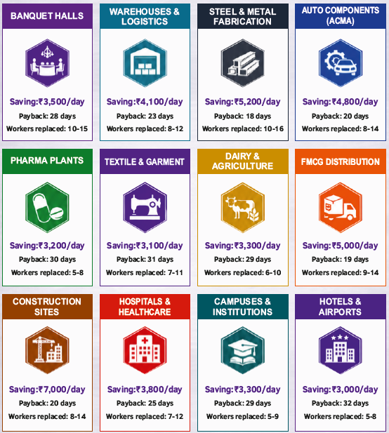

- FAQs: -
1. What is the load carrying capacity of the EV trolley?
The load capacity of MGT1000 is 1000 kgs. Our EV trolleys are available in multiple load capacities depending on industrial requirements and applications.
2. What is the running range on a single charge?
The range depends on battery configuration, load, and operating conditions. Typical running range is 35kms for MGT1000 model.
4. How long does charging take?
Charging time varies by battery type and capacity, generally between 4–8 hours. Fast charging charges the battery 100% in about 2.5 hours.
5. Can the trolley be customized?
Yes. We provide customization options for load body, dimensions, seating, battery capacity, branding, and application-specific requirements.
6. What industries can use Maxgreen EV Trolleys?
Factories, warehouses, resorts, hotels, hospitals, universities, airports, industrial plants, townships, and logistics facilities.
7. Is the trolley suitable for indoor factory use?
Yes. Since it is electric, silent, and emission-free, it is ideal for indoor operations.
8. What maintenance is required?
Very minimal maintenance compared to petrol / diesel vehicles. Regular battery care and periodic inspections are generally sufficient.
9. What is the battery life?
Battery life depends on usage patterns and maintenance, but our systems are designed for long operational durability. The battery warranty of MGT1000 model is 3 years.
10. Do you provide after-sales service?
Yes. Maxgreen provides dedicated service support, spare parts assistance, and technical guidance.
11. Is driver training required?
The trolley is simple to operate, and basic operational guidance is sufficient for most users.
12. How much cost can industries save by switching to EV trolleys?
Businesses can save significantly upwards of ₹ 20,000/- every month on fuel, maintenance, labour and operating expenses compared to conventional material handling vehicles.
13. Do EV trolleys require registration or RTO approval?
Low-speed industrial-use EV trolleys used within private premises do not not require registration.
14. Can the trolley operate on slopes and rough industrial roads?
Yes. Our trolleys are designed for industrial environments and can handle typical factory and campus road conditions including slopes and rough roads.

ABOUT US
- Keep Mission & Vision content as it is.
- 60+ years of Ambica (Maxgreen) Group’s experience
- 200+ dealers PAN India
- 25+ cities covered
- Remove the 4th Tile

Dhaivat Panchal Photo: -


Leadership Message: -
At Maxgreen, our vision is simple — to build practical, innovative, and sustainable machines that create real value for people and industries across India.
What started as a mission to support Indian farmers through electric mobility has now expanded into creating efficient EV solutions for industries, material handling, campuses, and commercial applications. We believe the future belongs to technology that is economical, reliable, and environmentally responsible.
Our focus has always been on understanding ground-level challenges and developing products that genuinely improve productivity while reducing operating costs. Every Maxgreen product is designed with durability, performance, and long-term value in mind.
We are committed to continuous innovation, strong customer relationships, and delivering dependable after-sales support. As we grow, our purpose remains unchanged — building machines that empower businesses, industries, and communities.
Thank you for being a part of the Maxgreen journey.
OUR SOLUTIONS
Models:-
- MGT1000 (platform trolley)
- MGT1000ECO (platform trolley)
- MGT600S (platform trolley)

MGT1000
Photo – I will share you all the photos model wise on your email address.
Technical Specifications
Overall Dimensions – 8 ft length x 4 ft width OR 6 ft length x 3 ft width
Motor Power - Robust BLDC Motor
Battery – LFP (3 years warranty)
Range – 4 hours / 35 kms per charge
Top Speed – 5 to 25 km/h (controllable as per requirement)
Cargo Capacity - 1000 kgs
Charging Time – 2.5 hours (Fast Charger) / 6 hours (Standard Charger)
Key Features
• Powerful Electric Performance
? Fog lamps + Side indicators
? Foldable side railings
? Collapsible steering handle
• Heavy-Duty Load Carrying Capacity
• Zero Fuel Cost Operation - SAVE ₹28,000+ EVERY MONTH PER TROLLEY
• Low Maintenance Design
• Silent & Eco-Friendly Running
• Strong Industrial-Grade Chassis
• Smooth Driving & Easy Handling
• Fast & Efficient Charging
• Ideal for Factories, Warehouses & Campuses
• Durable Suspension for Rough Internal Roads

4 TILES: -
Zero maintenance
Savings – ₹28,000+ every month savings per trolley
Battery – 3 years of company warranty
ROI – Return on investment in just 4 to 5 months.
INTERESTED IN “MGT1000” (Change the model name in this tile)

MGT1000-eco
Photo – I will share you all the photos model wise on your email address.
Technical Specifications
Overall Dimensions – 6 ft length x 3 ft width
Motor Power - Robust BLDC Motor
Battery – Lithium Ion - NMC (1 year warranty)
Range – 3 hours / 20 kms per charge
Top Speed – 5 to 25 km/h (controllable as per requirement)
Cargo Capacity - 1000 kgs
Charging Time – 6 hours (Standard Charger)

Key Features
• Powerful Electric Performance
? Collapsible steering handle
• Heavy-Duty Load Carrying Capacity
• Zero Fuel Cost Operation - SAVE ₹28,000+ EVERY MONTH PER TROLLEY
• Low Maintenance Design
• Silent & Eco-Friendly Running
• Smooth Driving & Easy Handling
• Fast & Efficient Charging
• Ideal for Factories, Warehouses & Campuses
• Durable Suspension for Rough Internal Roads

4 TILES: -
Zero maintenance
Savings – ₹28,000+ every month savings per trolley
Battery – 1 year of company warranty
ROI – Return on investment in just 4 to 5 months.

INTERESTED IN “MGT1000-eco” (Change the model name in this tile)

MGT600S
Photo – I will share you all the photos model wise on your email address.
Technical Specifications
Overall Dimensions – 6 ft length x 3 ft width (customizable)
Motor Power - Robust BLDC Motor
Battery – Lithium Ion - NMC (1 year warranty)
Range – 3 hours / 20 kms per charge
Top Speed – 5 to 25 km/h (controllable as per requirement)
Cargo Capacity - 600 kgs
Charging Time – 6 hours (Standard Charger)

Key Features
• Powerful Electric Performance
? Collapsible steering handle
• Heavy-Duty Load Carrying Capacity
• Zero Fuel Cost Operation - SAVE ₹28,000+ EVERY MONTH PER TROLLEY
• Low Maintenance Design
• Silent & Eco-Friendly Running
• Smooth Driving & Easy Handling
• Fast & Efficient Charging
• Ideal for Factories, Warehouses & Campuses
• Durable Suspension for Rough Internal Roads

4 TILES: -
Zero maintenance
Savings – ₹28,000+ every month savings per trolley
Battery – 1 year of company warranty
ROI – Return on investment in just 4 to 5 months.

INTERESTED IN “MGT600S” (Change the model name in this tile)

